Health Net Agent appointment process

- In order to get contracted with Health Net, you will need to have written or assumed your first piece of business.
  - You can add Jane Doe group with EIN 999-99-9999 to the application
**This was advised by Health Net Rep as to not hold up the appointment process

- The following will need to be completed through the Broker Self Service Web Tool
  - Health Net Agent/Broker Agreement
  - Web Registration
  - Online W-9 form
  - E&O report

- Both New and Existing brokers need to create a Contract Account using the Broker Self Service Web Tool. If you are already contracted with Health Net you can use this page to do the following
  - Update your name (only applicable if your TIN/SSN or license number Changes)
  - Update your address/phone/fax number
  - Enroll in EFT or change bank accounts
  - Complete web registration
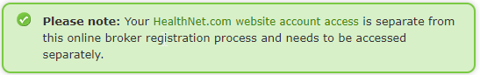

- When completing the online contacting documents, please ensure the following:
  - The name on the agreement, license and W-9 form match exactly
  - If paid to a corporation, make sure the corporation’s tax ID is provided
  - If paid to the broker, make sure the broker’s SSN or Tax ID is provided
  - License is current and active with the appropriate lines of authority, Accident, Health and Life

- If you have additional questions or need further assistance on how to become a Commercial Broker, please contact the Health Net Broker Services unit at 1 800 448 4411, option 4.

