Kaiser Agent Appointment process

- Login to your BrokerNet account
  - If you don’t have a BrokerNet account, click https://account.kp.org/broker-employer/resources/broker/floating/registration/ to get to the page below
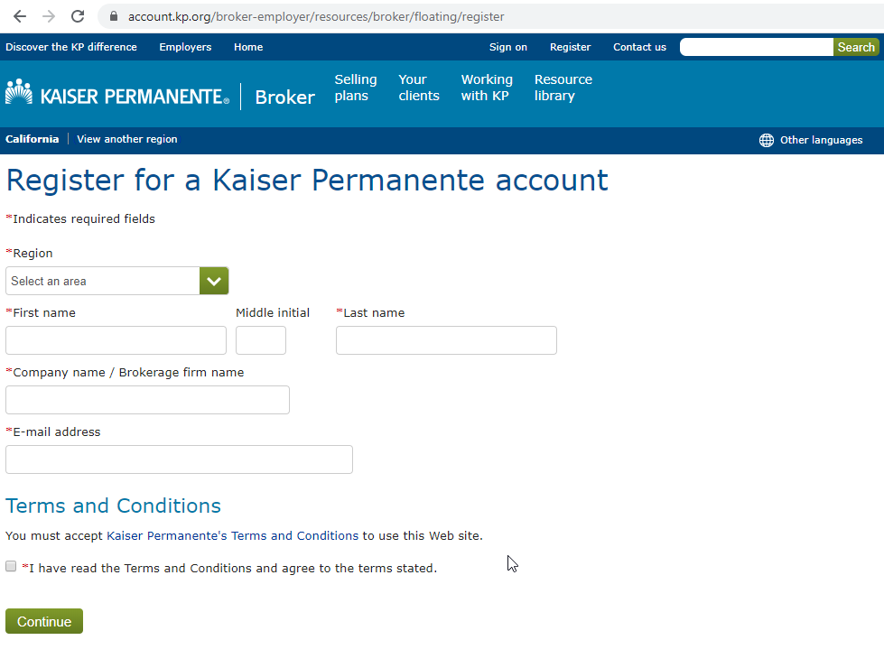

  - After registering, navigate back to the online Broker Appointment form to start your application. Simply select the "Get appointed to sell Kaiser Permanente" link on the home page

- Complete the online broker Appointment form
  - If you need to step away from this process, you can save your progress and return to the application later

- Upon completing the online application, you’ll receive a confirmation number letting you know your application has been submitted

- Once your application has been accepted, you’ll receive your broker ID number.
  - Please allow 10 business days for the appointment process to be completed
** If your firm is already appointed with us and you need to add an endorsed agent, you don't need to use the online broker appointment portal. Simply complete and email it to newkpbroker@kp.org
*** Please verify the agent you’re requesting to add to your firm is endorsed by and listed on the Department of insurance Website www.insurance.ca.gov If you are unsure of the agents status, you can review your firm’s endorsed agent list on the website. If you don’t have a designated firm license, you won’t be able to add sub-agents under your personal license.
Any question call Broker Services Team 800-789-4661 option 6

