Anthem Agent Appointment process

- Go to www.anthem.com

- Click Producers

- Click Start Selling Anthem Plans

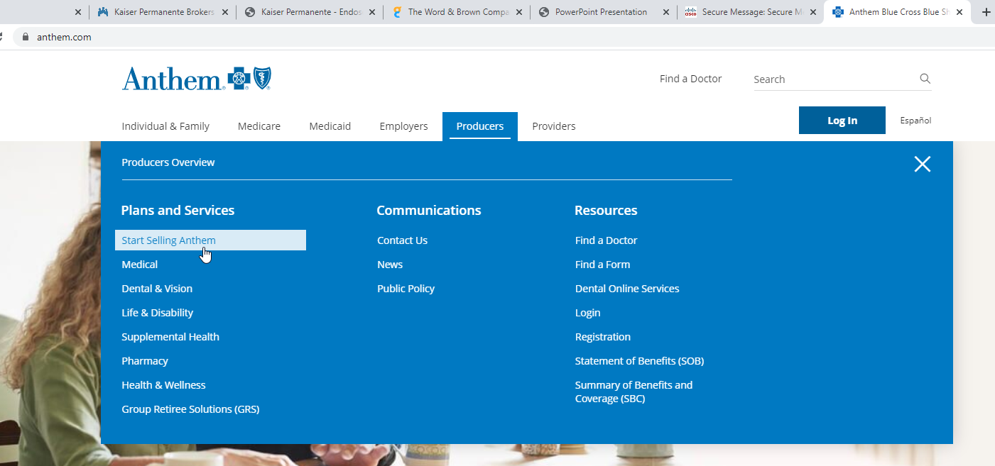

- Login to Producer Toolbox

- Scroll down to Need information

- This link will take you to NoMoreforms

- See PDF for NoMoreForms instructions

